ASPECTS REGARDING THE DEFORMATION OF CIRCUITE BOARDS

PhD. Assoc. Prof. XX
PhD. Assoc. Prof. YY
University “Politehnica” of Bucharest, Dept. of Mechanics

ABSTRACT

The paper studies aspects regarding the deformation of printed circuit boards, under certain loading conditions and by considering some simplifying assumptions. The mathematical model is presented, as well as a numerical example.

KEYWORDS: circuit boards, vibration

Introduction
The printed circuit board is a carrier for electronic components and it is used for mechanical fixing and for electrical connection. Basically, such a board is made of an insulating material (usually fiber reinforced plastic material or FRP Pertinax) with conductive adhesive connection (traces). The connections are usually made of a thin layer of copper on an electrically insulating substrate.
The manufacturing stages of such plates are the following: drilling, circuit, photo-resistant laminate, exposure, development, etching, washing, drying.

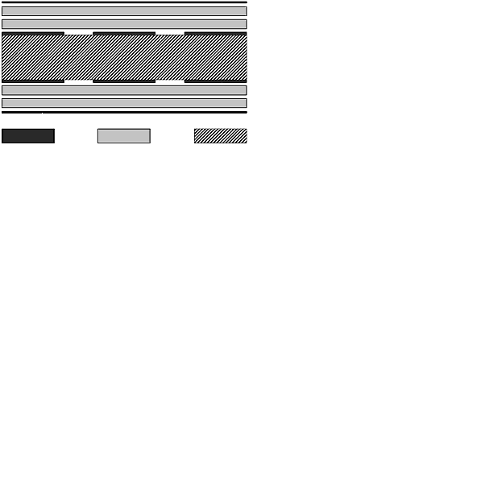 | 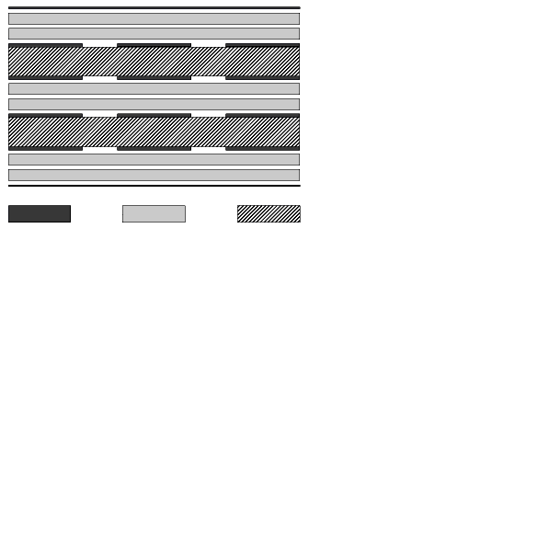
a) | b)

Fig. 1. Constructive solutions for circuit boards

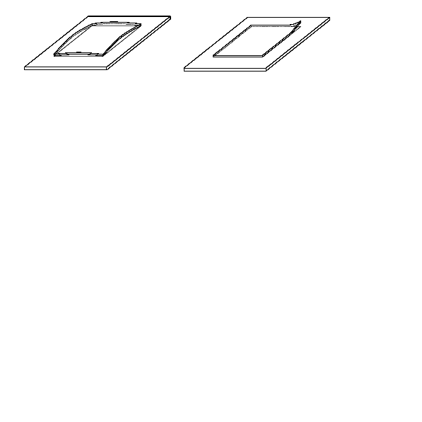
Fig. 2. Bending and out-of-plane deformation phenomena at circuit boards

Some existing constructive solutions are presented in Figure 1 [6].
Printed circuit boards can undergo bending or out-of-plane deformations [5] (Fig. 2).
Printed circuit boards of electronic devices can deform due to several causes, for example, as a consequence of initial out-of-plane deformations produced by handling during the assembly stage or as a result of dynamic loads induced by shocks and vibrations

MODEL and hypotheses
For the study of these phenomena, first, the case of a printed circuit boards is considered, equipped with terminal components mounted in axial passage holes (Fig. 3). In this situation, the deformation and the dynamic behavior of the plate is less influenced by the presence of components due to high elasticity of their terminals [4].

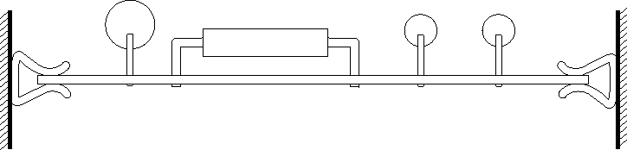
Fig. 3. Circuit board equipped with axial terminal components

The study of the dynamic behavior of the circuit board is developed analytically, in accordance with known methods for the study of plane plates [1], [2], by assuming the following hypotheses: uniform structure, isotropic material behavior, uniform distribution of the additional load produced by the mass of the components that equip the board.
The calculation formula [1] for the circular eigenfrequency of the plate – assimilated to a simple oscillating system – is a combination of trigonometric or polynomial functions which approximate the deformed shape of the plate, in relation with the contour conditions (simple support, rigid fixing, free) and it has the form

$ω_{P}=\frac{f\left(λ\right)}{a^{2}}\sqrt{\frac{D}{m}}$, ()

where the following notations have been introduced:
$a$ - length of the small side of the board;
$b$ - length of the large side of the board;
$c$ - width of the plate;
$m=ρ⋅c+\frac{m_{\text{comp}}}{a⋅b}$ - total superficial density of the board;
$ρ$ - density of the board material;
$m_{\text{comp}}$ - mass of the components mounted on the board;
$λ=\frac{a}{b}$ - slenderness ratio;
$f\left(λ\right)$ - coefficient dependent on the contour conditions and on the slenderness ratio;
$D=\frac{E⋅c^{3}}{\text{12}\left(1−ν^{2}\right)}$ - bending rigidity of the board;
$E$ - Young's modulus of the board material;
$ν$ - Poisson's coefficient of the board material.
The expressions of the coefficient $τ=\sqrt{\frac{1+d^{2}}{{\left[1−{\left(\frac{ω}{ω_{P}}\right)}^{2}\right]}^{2}+d^{2}}}=\sqrt{\frac{1+0\text{.}{\text{06}}^{2}}{0\text{.}{\text{06}}^{2}}}=\text{16}\text{.}\text{69}$ are presented in Table 1 [4] and its variation for two representative cases is shown in Figure 4.
The guides that hold the board and the connectors correspond to simple supports, while the sticking to a rigid frame can be considered as a rigid fixing. It should be mentioned that, depending on the loading level, the attachment system can behave in a different way, which makes it necessary to change the contour conditions. In this sense should be considered a guide which holds the board in the desired position, under the pressing force obtained by pretensioning an elastic element. Thus, the displacement of the margin is allowed only after the inertial forces developed by the plate exceed the force obtained by pretensioning the spring, which makes the side behave like a free one.
The coefficient of mechanical losses speciffic to the glass textolite depends on the frequency and amplitude of the vibrations.
For instance, for a board with the dimensions 190 x 140 x 2 mm, the values corresponding to the first three eigenforms are 0.064, 0.027, 0.016 [4].

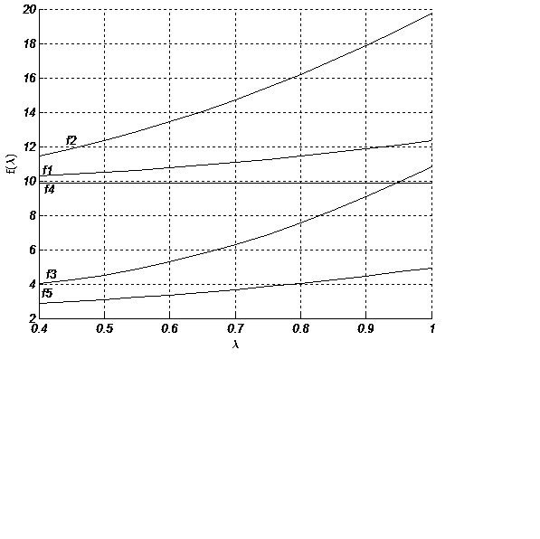
a) Material with $ν=0\text{.}\text{25}$

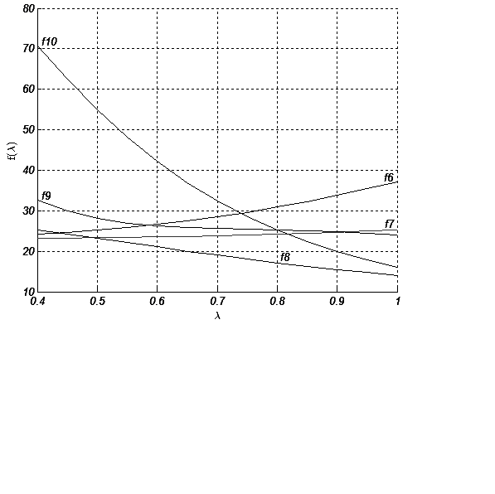
b) Material with $ν=0\text{.}\text{22}$

Fig. 4. Variation of coefficient $f\left(λ\right)$ for tow types of materials

The transmissibility is deteremined by means of an empirical formula:

$T=α\sqrt{f_{p}}$, ()

where the following notations have been introduced:
$f_{p}=\frac{1}{2π}ω_{p}$ - eigenfrecquency of the board;
$ω_{p}$ - circular eigenfrecquency of the board ();
$α∈\left[0\text{.}5, 2\right]$ - a coefficient dependent on the eigenfrecquency and on the damping coefficient of the plate (the inferior limit corresponds to values less than 100 Hz and to additional damping, while the superior one corresponds to values greater than 600 Hz and to the lack of damping) [4].

Table 1
Plate $λ=\frac{a}{b}$ | $$f\left(λ\right)$$
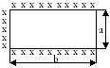 | $$f_{1}\left(λ\right)=π^{2}\left(1+\frac{λ^{2}}{4}\right)$$
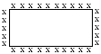 | $$f_{2}\left(λ\right)=π^{2}\left(1+λ^{2}\right)$$
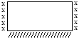 | $$f_{3}\left(λ\right)=π^{2}\sqrt{0,\text{126}+0,\text{08}λ^{2}+λ^{4}}$$
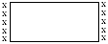 | $$f_{4}\left(λ\right)=π^{2}$$
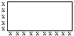 | $$ϕ_{5}\left(λ\right)=\frac{π^{2}}{4}\left(1+λ^{2}\right)$$
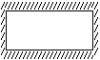 | $$f_{6}\left(λ\right)=\frac{4π^{2}}{3}\sqrt{3+2λ^{2}+3λ^{4}}$$
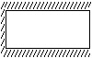 | $$f_{7}\left(λ\right)=\frac{2π^{2}}{3}\sqrt{\text{12}+2λ^{2}+\frac{3}{4}λ^{4}}$$
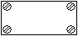 | $$f_{8}\left(λ\right)=\text{18},\text{33}\sqrt{\frac{\frac{5}{2}\left(1+\frac{2}{3}λ^{2}+λ^{4}\right)+ν\left(1+λ^{4}\right)}{1+3λ^{2}+\frac{\text{21}}{5}λ^{4}+3λ^{6}+λ^{8}}}$$
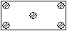 | $$f_{9}\left(λ\right)=\text{13},\text{66}\sqrt{\frac{\frac{1}{λ^{2}}\left(1−\frac{4}{3}λ^{2}+\frac{\text{32}}{3}λ^{4}−\frac{4}{3}λ^{6}−λ^{9}\right)+\frac{3}{8}ν\left(1+\text{22}λ^{2}\right)}{1+\frac{\text{11}}{9}λ^{2}+λ^{4}}}$$
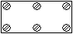 | $$f_{\text{10}}\left(λ\right)=\text{114},\text{46}\sqrt{\frac{1+\frac{8}{\text{13}}λ^{4}+\frac{5}{\text{13}}ν}{1+7λ^{2}+\frac{\text{119}}{5}λ^{4}+\text{36}λ^{6}+\text{18}λ^{8}}}$$
Legend: free side
xxx simply supported side
///// rigidly fixed side
attachment with screws

The second study method consists in modeling the board as a multi-degree-of-freedom system (). In this case the transmisiblity is determined experimentally.
The relative displacement between the component and the connection point of the terminal ($δ$) can be calculated starting from the displacement differential equation of the plate [2]:

$∇^{4}w=\frac{p}{D}$, ()

where $D$ is the plate rigidity, while $p$ is the surface distributed load of the plate.

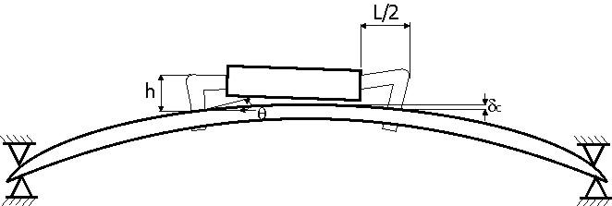
Fig. 5. Deforming of the circuit board and of the axial terminal components

In order to simplify the calculations, an approximate relation is considered for the variation of the deflection $w$:
- for the plate simply supported on the contour,

$w_{x}=w_{0}\text{sin}\frac{πx}{a}$; ()

- for the plate rigidly fixed on the contour,

$w_{x}=\frac{w_{0}}{2}\left(1−\text{cos}\frac{2πx}{a}\right)$. ()

The maximal deflection $w_{0}$ in the case of the deforming due to shocks and vibrations can be calculated with the relation [1]

$w_{0}=\frac{F}{k}$, ()

where the following notations have been used:
$F=M⋅\tilde{a}$ - force induced on the circuit board;
$M$ - mass of the board;
$\tilde{a}$ - acceleration;
$k=\frac{4π^{2}f_{p}}{M}$ - rigidity of the board.
For a component placed at the middle of the board, where the displacement is maximal, with the terminal at the distance $x$ from the margin, the expressions of the diplacement and of the rotation, respectively, can be written,

$δ=w_{0}−w_{x}, θ=\frac{\text{dw}}{{dθ}_{x}}$, ()

which, for a plate with simply supported margins, lead, by using (), to the relations:

$δ=w_{0}\left(1−\text{sin}\frac{πx}{a}\right) , θ_{A}=w_{0}\frac{π}{a}\text{cos}\frac{πx}{a}$. ()

Under the assumption that the loads and the relative displacements are suported only by the terminal conductors of the component, only the structure corresponding to the terminals will be taken into account, representing a rectangular frame, rigidly fixed at both ends [3] (Fig. 6). The frame can be analysed as a statically indeterminate system, for which the resultant displacements are kown (the deflection at the middle and the rotations in the rigid fixings). The system is obtained by superimposing a given load produced by a vetical virtual force $P$ and by a bending moment $M$ (Fig. 6).
The analytical results existing in the literature [5] for different loading cases are presented in the following, by computing $θ_{A}$ with relation () and by introducing the parameter characterising the geometry of the frame

$K=\frac{E_{1}I_{1}}{E_{2}I_{2}}\frac{h}{L}$. ()

Fig. 6. Terminal conductos of the component (statically indeterminate frame)

For the loading with a concentrated force P, applied at the middle of the horizontal portion (Fig. 7) it results:

$M_{A}=\frac{\text{PL}}{4K+\text{16}}$, ()

$H=\frac{3\text{PL}}{2h\left(4K+8\right)}$, ()

$V=\frac{P}{2}$, ()

$δ=\frac{{\text{PL}}^{3}}{\text{48}E_{1}I_{1}}\left(1−\frac{3}{2K+4}\right)$, ()

$M_{E}=\frac{\text{PL}}{4k+8}\left(K+1\right)$. ()

a)
b)
Fig. 7. Loading with a concentrated force applied at the middle of the horizontal portion

a)
b)
Fig. 8. Loading with a concentrated moments in the simple suppors

For the loading with the concentrated moments M_{A} in the simple supports (Fig. 8), it results:

$M_{A}=\frac{2θ_{A}\left(3+2K\right)E_{2}I_{2}}{h\left(2+K\right)}$, ()

$H=\frac{2θ_{A}\left(3+2K\right)E_{2}I_{2}}{h^{2}\left(2+K\right)}\left(1−K\right)+\frac{4E_{1}I_{1}θ_{A}}{\text{hL}}$, ()

$δ=\frac{θ_{A}L}{4}\left(2−\frac{3+2K}{2+K}\right)$, ()

$M_{E}=−\frac{4E_{1}I_{1}θ_{A}}{L}+\frac{2{Kθ}_{A}\left(3+2K\right)E_{2}I_{2}}{h\left(2+K\right)}$. ()
For the simultaneous loading with the force and the moments, it results:

$M_{A}=\frac{\text{PL}}{8K+\text{16}}+\frac{2E_{2}I_{2}θ_{A}}{h}\left(\frac{3+2K}{2+K}\right)$, ()

$\begin{aligned}H=\frac{3\text{PL}}{2h\left(4K+8\right)}+ \\ +\frac{2θ_{A}\left(3+2K\right)E_{2}I_{2}}{h^{2}\left(2+K\right)}\left(1−K\right)+\frac{4E_{1}I_{1}θ_{A}}{\text{hL}} ,\end{aligned}$ ()

$V=\frac{P}{2}$, ()

$\begin{aligned}δ=\frac{{\text{PL}}^{3}}{\text{48}E_{1}I_{1}}\left(1−\frac{3}{2K+4}\right)− \\ −\frac{θ_{A}L}{4}\left(2−\frac{3+2K}{2+K}\right) ,\end{aligned}$ ()
$\begin{aligned}M_{E}=\frac{\text{PL}}{4K+8}\left(K+1\right)− \\ −\left[\frac{4E_{1}I_{1}θ_{A}}{L}−\frac{2{Kθ}_{A}\left(3+2K\right)E_{2}I_{2}}{h\left(2+K\right)}\right] \text{.}\end{aligned}$ ()

Numerical ApPLICAtion
A circuit board is considered with the dimensions $\text{175}×\text{175}×1\text{.}5 \text{mm}$ [4] ($ρ=1\text{.}9⋅{\text{10}}^{3}{\text{kg/m}}^{3}$, $E_{\text{st}}=1\text{.}8⋅{\text{10}}^{4}{\text{N/mm}}^{2}$, $ν=0\text{.}\text{25}$), equipped with axial terminal components, whose dimensions are presented in Figure 9 and with the mass $m_{\text{comp}}=0\text{.}1 \text{kg}$.
The board vibrates in the frequency domain 10-500Hz, respctively, with the amplitude of 0.35 mm up to the transfer frequency of 60Hz and with a maximal accelaration of $2g$ for the frequencies which exceed this value (according to STAS 8393/9-81).
The circular eigenfrequencies of the board, for various attaching systems, according to Table 1, are presented in Figure 10 ($m=6\text{.}\text{11} {\text{kg/m}}^{2}$, $a=0\text{.}\text{175} m$, $c=0\text{.}\text{0015} m$, $D=5\text{.}4 N⋅m$).

Fig. 9. Circuit board

f  [Hz] | 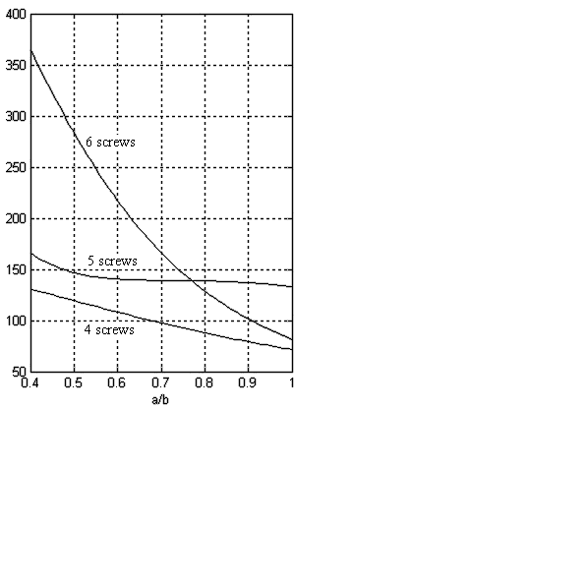

Fig. 10. Eigenfrequencies of the circuit plate

The board is presumed simply supported on all sides, with the component terminals made of nickel wire ($φ=5 \text{mm}$, $E_{\text{Ni}}=2⋅{\text{10}}^{5}{\text{N/mm}}^{2}$). In order to determine the loadings in the characteristic points of the component terminals, the calculation steps presented above are followed. The following results have been obtained:
- The resonance frequency of the board: $m=6\text{.}\text{11} {\text{kg/m}}^{2}$, $f\left(λ\right)=\text{19}\text{.}\text{73}$, $D=5\text{.}4 N⋅m$, $ω_{P}=\text{605}\text{.}6 \text{rad/s}$, $f_{P}=\text{96}\text{.}\text{43} \text{Hz}$.
- Transmissibility at resonance ($ω=ω_{P}$): of the oscillating system represented by the board, corresponding to a hysteretic damping coefficient $d=0\text{.}\text{06}$: $τ=\text{16}\text{.}\text{69}$.
- Maximal vibration amplitude of the support of the board, corresponding to the frequency of $\text{96}\text{.}\text{43}$ Hz and to the acceleration $2g$: $A=0\text{.}\text{053} \text{mm}$.
- Vibration amplitude of the board at resonance: $w_{0}=0\text{.}\text{89} \text{mm}$.
- Displacement and rotation (): $δ=0\text{.}\text{03} \text{mm}$, $θ_{A}=3\text{.}9⋅{\text{10}}^{−3 } \text{rad}$.
- Parameter characterising the geometry of the frame: $K=0\text{.}\text{23}$.
- Bending rigidity of the terminal cross-section: $\text{EI}=\text{613}\text{.}6 N⋅{\text{mm}}^{2}$.
- Virtual force $P$ producing the same displacement as the one corresponding to the deformation: $P=1\text{.}\text{44} N$.
- Bending moments and reactions in the characteristic points of the frame: $M_{A}=3\text{.}\text{58} N⋅\text{mm}$, $M_{B}=2\text{.}\text{27} N⋅\text{mm}$, $H=1\text{.}\text{95} N$, $V=0\text{.}\text{72} N$.

CONCLUsions
Starting from the practical situations regarding the deformation of circuit boards and from their constructive solutions, the paper examines two cases considered relevant. For the hypothesis that the loads and the relative displacements are supported only by the component terminal conductors, which means that only the structure corresponding to the terminals will be considered, a model is adopted, representing a rectangular frame, rigidly fixed at both ends. The frame can be examined as a statically indeterminate system, for which the resulting displacements are known (deflection $δ$ at the middle and rotations in the rigid fixings) for various load conditions. The calculation was developed for this complex possibility.
It can be concluded that, the neglection during the design and manufacturing, of the effects of the circuit board deformation can cause non-functionalities of electronic devices which are made up of such boards and, therefore, low reliability, with predictable negative economic consequences.

References
- Deciu, E., Dragomirescu, C., Maschinendynamik, Ed. Printech, Bucureşti, 2001.
- Frischer, U., Magdeburg, G., Stephan, W., Mechanische Schwingungen, VEB Fachbuchverlag Leipzig, 1984.
- Hauger, W., Schnell, W., Gross, D., Technische Mechanik 3, Kinetik, Springer Verlag, Berlin Heidelberg, 2002.
- Pascu, A., Structura mecanică a aparatelor electronice, OID-ICM, Bucureşti, 1992.
- Voinea, R., Deciu, E., Dragomirescu, C., Technische Mechanik, Ed. ALMA Craiova, 2009.
- http://www.db-electronic.com/index.php?nav3&subnav=4&tipp=1&lang=de.

